# SYSTEM SPECIFICATION

## FUNCTIONAL SPECIFICATION

### Required System Overview

|  |  |  |
| --- | --- | --- |
| Business Needs | Major Features | System Related Functions |
| Music Pattern Learning | Learn melody patterns from provided sheet music and compose music from what the application has learned | Sheet Music Reading, Analysis, Analysis Storage, Music Composition |

#### MMFI-01 Read Midi

|  |  |
| --- | --- |
| Item | Description |
| Function ID | MMFI-01 |
| Function Name | Read Midi |
| Category | Data Access layer |
| Function Description | This function reads the midi file and extracts the data stored in the file for later analysis |
| Mode | batch |
| Frequency | When invoked |
| Special Service Level Requirements | N/A |
| Data Integration and Conversions | N/A |
| Business Rules | Check if valid midi file |

#### MMFI-02 Analyse Data

|  |  |
| --- | --- |
| Item | Description |
| Function ID | MMFI-02 |
| Function Name | Analyse Data |
| Category | Business Layer |
| Function Description | This Function takes the raw data that was gathered in the function ‘Read Midi” and does an analysis of the pattern and creates a neural mapping or updates the existing one. |
| Mode | Batch |
| Frequency | When invoked |
| Special Service Level Requirements | N/A |
| Data Integration and Conversions | N/A |
| Business Rules | If a neural mapping exists the application should use it and add what it learns from new sheet music to improve on what it has learned from previous experiences. |

#### MMFI-03 Compose Music

|  |  |
| --- | --- |
| Item | Description |
| Function ID | MMFI-03 |
| Function Name | Compose Music |
| Category | Business Layer |
| Function Description | This function will make use of the neural network to compose sheet music in a chosen key and create a midi file with the sheet music. |
| Mode | batch |
| Frequency | When invoked |
| Special Service Level Requirements | N/A |
| Data Integration and Conversions | N/A |
| Business Rules |  |

## ARCHITECTURE DESIGN

## Application Architecture

### Security

Neural network based applications have been used successfully in the area of networks security as an intrusion detection system, misuse detection and firewalls. Also, in the field of application security, neural network has been proposed to be a virus detection system. It would be noticed however, that these neural networks can only provide a form security after software deployment. The project manager is in charge of deciding who the information of the system be given to, the client is the one who has the most rights to have any information related to the proposed system.

The availability of the information of the system will be given according to the roles the people play in the actual development of the system.

The artificial neural network voltage security monitoring and control is used. The neural network uses its association mechanism, the inherent parallel information processing nature of the neural network, which provides the capability of fast computation, enables the neural network approach to meet the demands of real time monitoring control

## SYSTEM DESIGN

### Common Frameworks

|  |  |
| --- | --- |
| Validation | * Validate midi input |
| Exception handling | * Throw error when invalid input * Throw error when invalid file input * Throw error when a file cannot be composed |

## Design

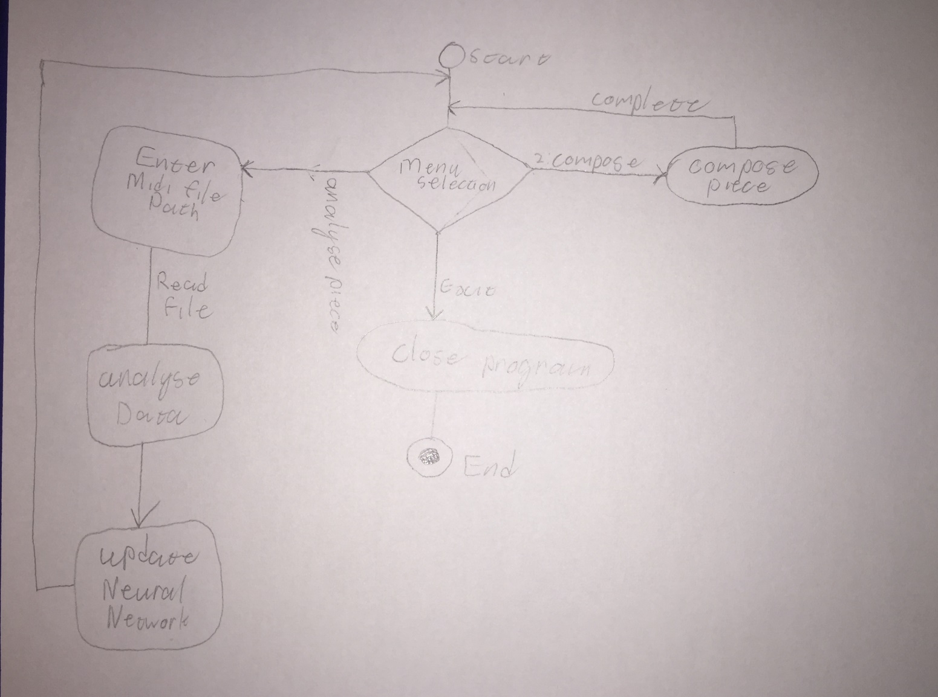

## User Experience Design

The project will use a text interface with the options:

1. Analyse Midi
2. Compose Piece
3. Exit

## Data Model

